Media Manipulation: Rhetorical Analysis

Read the following [article:](https://medium.com/@eziana/rule-1-corollary-a-how-to-spot-media-manipulation-fakenews-e0b567f65202)

I’m getting a little frustrated seeing educated people easily manipulated and scammed by social media and even mass media. But I recognize that it’s not entirely their fault (see [this comic, AGAIN](https://theoatmeal.com/comics/believe)). I’m concerned, dear reader, about your well-being. We simply can’t allow fake media and misleading claims to saturate our lives and blatantly manipulate our beliefs and emotions.

But I can help — and I *should* help. During my time doing scientific research, I focused on trust development. (I can probably tell you more about behavioral economics, both large and small scale, than the CEOs of some Fortune 500 companies!) There’s a lot you can learn here. Hopefully you’ll come away with the skills to spot this the next time you see someone share news, opinion articles, or videos on social media.

For the remainder of this entry, I’m putting a moratorium on my self-imposed “no science” rule. So, I apologize if you learn something sciencey and you weren’t intending to stop in for some education.

This post will be about how you can spot deceptive, misleading, and often times false information in media cleverly designed and hidden to trick you into believing it to be fact. How do they do that? *Psychology*. Very old psychology that ***manipulates the trust of you, the consumer***. That’s right, we’re gonna talk about Conmen and The Art of the Con (see also [Confidence Trick](https://en.wikipedia.org/wiki/Confidence_trick)).

*For reference to the title, see my post on* [*Rule One — Social Toxicity Check.*](https://link.medium.com/3FlGlR4W1U) *These two go hand-in-hand.*

But first, let’s talk a bit about Trust. I’m going to use to [socio-cognitive model of trust](https://www.amazon.com/Trust-Theory-Socio-Cognitive-Computational-Model/dp/0470028750) as descriptive device. It’s not perfect, but it’s simple and functional for this purpose. We’ll start with a basic definition of what trust is as derived from this theory:

*Trust is a process in which a trustor evaluates whether she can delegate a task (or knowledge belief) to a trustee based on the expectation that the trustee will perform actions to complete the task (or deliver the information) in question. This process is relative to the immediacy of the goal — the less time available, the less belief is required to act.*

We’re going to shift from the task stuff and focus on the knowledge part of that and media. The model describes that trust can be broken down into these pieces that a trustor (in this case, media consumer — you) evaluates:

*Competence — does the source seem knowledgeable in the area they are discussing?*

*Fulfillment — do you think the source will deliver true and correct information?*

*Dependence — is this the only (or one of a few) source, in the time that you have, that can deliver the information you’re looking for?*

*Predictability — is the source likely to deliver information that confirms what you already suspect?*

Predictability is further divided into:

*Disposition — does this source intend to pass this information-are they motivated for their own reasons to pass on this information?*

*History — has this source delivered a positive experience in the past?*

*Willingness — is the source willing to pass on their knowledge? (Somewhat goes without saying for Media.)*

*Self-Confidence — does the source seem to believe what they are saying?*

Let’s look at this from the Stages of the Con (this list has a bunch of different variations, but they all work mostly the same — identify victim, manipulate, scam, leave). We’re going to start by handing the conman “self confidence” for free — they’re going to act confident at various stages of this process.

## **The Approach**

you, the victim, are identified: do you seem like you would be invested in the fake rewards of the con? (*Fulfillment, Dependence*).

## **Build-up**

The emotional manipulation stage. You are encouraged to believe the conman has expertise or knowledge in one or more areas (*competence*). He’s just like other people you’ve met before (*history*). The conman will make attempts to appear on the “same team” as the you (*history, disposition*). They’ll build up a case against the opposing team using real facts (*fulfillment*), and state how they’re going to help give better information (*willingness, fulfillment*). They may casually insult or name-call “the enemy team” (*self-confidence, competence, disposition*).

## **Pay-off/Convincer**

You’ll be encouraged by some instant benefit (*money*, or *validation* of current beliefs).

## **The Hurrah**

A sense of immediacy is attached by some threat or risk (lowers belief level to act, w*illingness*) and you have to act now (*dependence, fulfillment*)

With some cons, additional inside-people are used to add legitimacy to the scam (nearly all beliefs can be a target here, the conmen will try to find the low beliefs and raise them — *competence, fulfillment, disposition, history, willingness*) — **The In-And-Out**

## **What does this look like in Digital Media?**

You may not see all of these stages — in fact, social media (by it’s social nature) makes some of them irrelevant. The Approach is different, because it works by targeting an easily manipulatable audience (for example, an anti-vaccination video to extreme left anti-fascists). These people, in turn, share the media with others, who share it with others, all the way down a chain. With each step that passes, the media is more likely to arrive at a willing victim (remember, that’s you), because you already trust your friends to a certain degree (who trusted their friends, who… you get the idea). This doesn’t succeed with everyone, but by that point, a single individual has started a network of cons targeting *thousands*. Your friends sharing these things operate, unknowingly, as ***the In-And-Out***. The media itself will try to add a sense of urgency based on an upcoming election or legislative/judicial action (The Hurrah), and the media will likely start by confirming an assumption you already believe (pay-off).

*In media, often The* ***Hurrah*** *may come in the introduction, rather than towards the end.*

## **Example 1 — Extreme Left Wing “News”**

Let’s look at some concrete examples. Here’s one that a lot of people are willing to agree with pretty quickly — and I’m not saying that the conclusion is wrong, only that the author arrives at it by manipulation rather than facts. Remember, this article came *to you*, so the Approach is covered — but we’ll include the title as part of it.

The Palmer Report: <https://www.palmerreport.com/analysis/rubber-room-trump-belong-d/16681/>

Quick analysis:

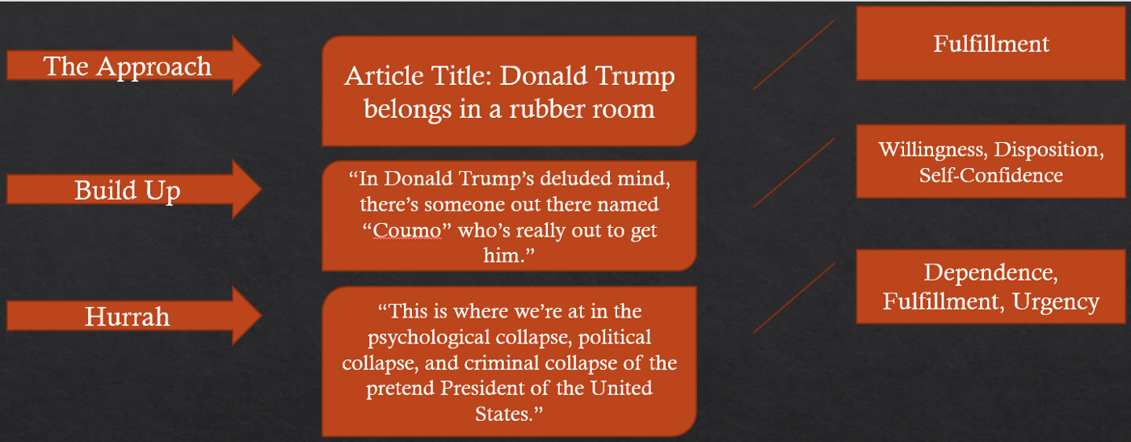

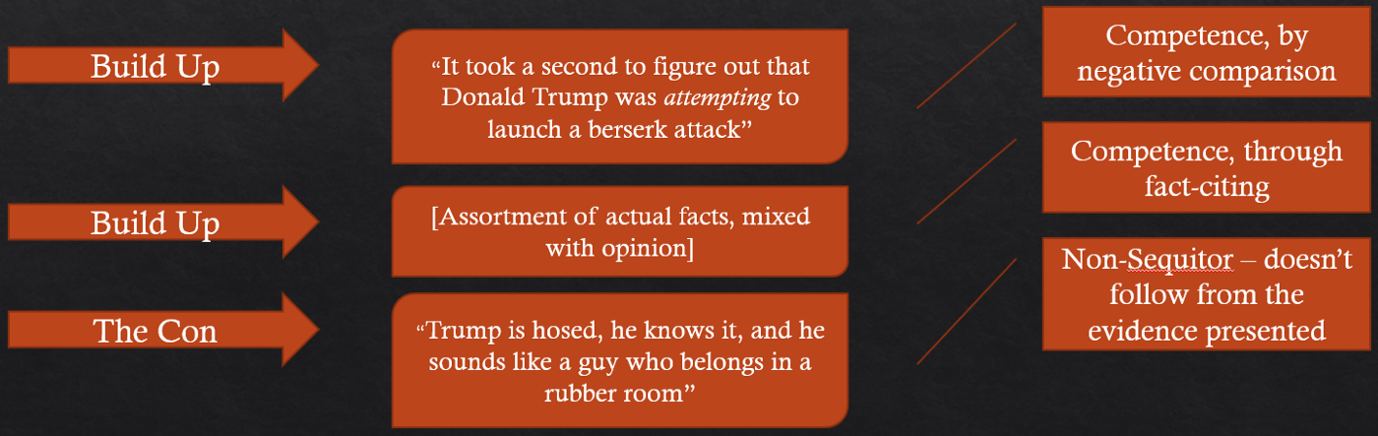

In this example, we see a variety of trust manipulation tactics. The site title is somewhat deceptive by including “report” to legitimize the content as news. The con itself is actually included in the essay title, and repeated at the end. However, the only “fact” used to back it up in the entire article is a typo in a tweet. That’s in no way a basis for the conclusion. But a lot of people will believe it, simply because 1) they want to, and 2) they’ve been manipulated into a state where they are likely to.

Left-wing media can be a bit more difficult to analyze except for some extreme examples like above — they tend to be a bit more subtle in their manipulation than the right. They have to be, because their target audience (victims) typically have a very low “[need for cognitive closure](https://en.wikipedia.org/wiki/Closure_(psychology))”. They appreciate ambiguity and reject strict interpretations. Never-the-less, you’ll see some examples that follow the formula pretty often (occasionally Rachel Maddow will slip into it, and the Huffington Post is full of contributors following the manipulation script).

But if you want to see classic, and repeated follow-through on the “how to manipulate others” guide, you really have to look to the far-right.

Example 2 — Extreme Right Wing “Educational Organization”:

I’m not even going to get into Ben Shapiro at this point — his book “How to Debate Leftists and Destroy Them” is basically a cleverly disguised instructional copy of “[The Confidence Game: Why We Fall for It. . . Every Time](https://www.amazon.com/Confidence-Game-Fall-Every-Time/dp/0143109871)”. Expert con-artist for the digital age. That’d be *too easy*.

So let’s talk about Prager University. Right off the bat, we’re looking at manipulation — Prager is in no way a university, accredited learning institution, and their speakers are often not teachers or professors. Same tactic as Palmer, but much more direct. Here’s a specific example making the rounds:

PragerU Video: <https://www.youtube.com/watch?v=Aer3mvlLVZw>

0:00 — Leads with Alexandria Ocasio-Cortez fumbling a bit through a question about capitalism. She sucks at public/improvisational Q-and-A, that’s true. However, this is still the same type of evidence as Trump’s twitter typos.

0:32 — You’re passed to the con-artist. “So wrong, it’s exactly backwards and I’ll prove it to you”. Establishes himself as an expert by negative comparison and claiming to have proof.

0:37 — “Been on Amazon lately?” — establishing shared **history**, “we’re on the same team”

0:46 — “Each of the thousands of products amazon offers represents the work of people who believe they have something to offer that you want or need.” The first con — it goes by quickly, so most people wouldn’t notice it. But it isn’t true. People make things for sale for a variety of reasons, including simple personal expression or supporting a cause. Not all businesses are created for a direct market need. This lie is repeated later on “no one starts a business making something or providing a service for themselves”. Yes, they do. But these statements are part of the *Build-up* (*the Rope*), to establish *competence*, *self-confidence*, and for some others (like some small business-owners) **disposition** — “I know what I’m talking about, and I’m on your team, so you should listen to me”.

1:07 — Alexandria Ocasio-Cortez: “when we talk about ideas, for example, democratic socialism, it means putting democracy and society first, instead of capital first”. This isn’t worded well, but it isn’t factually incorrect either. However, it acts as the setup for *the convincer* (see next) and inspires a sense of immediacy (*the hurrah*) by introducing a threatening topic (see [this comic again, and again](https://theoatmeal.com/comics/believe)).

1:16 — “In a socialist economy, the government has the ultimate power”. Here’s the second con, assuming you fell for the first one. The con-artist provides **no evidence** for this statement. *He isn’t qualified or experienced in political science in any way*. And he’s “entirely wrong”. He’s describing a **communist** *nationalist* economy (authoritarian large-government socialism).

Democratic socialism is small-government with distributed authority (otherwise known as democracy) — the government has **limited to no** direct control over private enterprise, *but workers should share partial ownership of their employer (for example, stock ownership).*

Other than safety regulations and some tax difference, *the free market still exists and functions with supply/demand, etc*.

1:39 — “Have you ever noticed that late-stage socialist failures always run out of essentials like toilet paper?”. Again, he provides no evidence of this claim — it’s designed to build fear (establishing *willingness*, *fulfillment*, and *dependence* beliefs). There ***haven’t been*** any late-stage democratic socialist failures.

2:05 — “I speak from personal experience. When I was the CEO of the company that owns Carl’s Jr. and Hardees…”, name-dropping to establish *competence* belief.

But I’ll stop there — the rest continues to **build up fear** using half-truths and mis-represented information ***to manipulate you***, *the viewer*, into a place where you are unable to look objectively at the content. The whole video is only 3 minutes long. Less time than it took to read this — the short duration only adds to the immediacy, increasing your *dependency* on the news source, and tricks you into thinking it will *fulfill* your future informational needs.

The trick is noticing the switch from *facts to deception*. Once you believe the first lie, it’s much easier for you to believe the next one, and the next. Until the entire argument seems perfectly reasonable. This is the reason that the first con is usually believable on its own, and is usually rooted in a partial truth. It’s easy to turn a partial skeptic into a full-time believer by feeding them increasingly small bites of truth.

Can you spot the things in this entry that were designed to manipulate you? Compare it to my other entries for style and it should be readily apparent.

[(Links to an external site.)](https://medium.com/@eziana/rule-1-corollary-a-how-to-spot-media-manipulation-fakenews-e0b567f65202)

and analyze it for the rhetorical situation and rhetorical devices. Then write an intro paragraph to a rhetorical analysis essay with a hook, a topic sentence that offers a strong controlling idea, and a 'funnel' that moves from the broader topic to a thesis statement that addresses the way at least three rhetorical devices support the author's message.

## Rhetorical Situation

| Exigence | How mass amount of people are getting scammed by social media |
| --- | --- |
| Purpose | To educate and inform the public about misinformation |
| Audience | Everybody online |
| Context | There is a lot to consume in this new digital age and it can be difficult |
| Message | Fake news is dangerous to the public, and people need tools in order to discern the truth and prevent bias. |

## At least three rhetorical choices and their effects:

Intro Paragraph:

In this age of technology, millions of people are constantly uploading, watching and scrolling through social media. Their brains absorbing information at a rapid pace, but not all of this information is accurate, and this misinformation can lead to people creation unconscious biases. In her article “How To Spot Media Manipulation” Eziana Sephiriel is concerned about the large scale effects fake news can have on society and wants to help people understand how to filter false information. In her article, Sephiriel argues that Fake news is dangerous to the public, and people need tools in order to discern the truth and prevent bias through the use of pointed diction, parallelism and ethos.

## Body Paragraph:

The author uses aggressive and assertive words through her writing to convince the reader of her sincerity and concern. By including the reader in the text conversationally, she is able to better convis the readers of her claims. The author states that ”With each step that passes, the media is more likely to arrive at a willing victim (remember, that’s you), because you already trust your friends to a certain degree” with the use of words such as “willing victim” she is sympathizing with the reader, and showing the reader as a clueless victim who needs her help. This pushes the reader to believe that they need her advice, and tools in order to not become a victim. It can also indicate that the author is a caring person, who is worried about the innocent and “willing” victims. These words push the blame away from the person, and give an image to ignorance instead or carelessness. The author also frequently uses “you” throughout the article in order to speak directly to the reader, and further pull them into the article. Making the reading experience feel more like a conversation with an author. The author uses this inclusion and sympathetic diction, to convince the reader they need her tools and skills in order to decent the truth through the internet.

Conclusion

The concern about safety online is only increasing, as digital presence grows in importance. People live their entire lives online, and it is the easiest way to find and release information. And with so much accessible information, it can be difficult to decern what is true and what is not. And when “fake news” is spread on mass, there can be disastrous consequences. Eziana Sephiriel like many others is worried for the future of humanity as people continuance to create unconscious biases and for opinions on false information. So, it is important for everyone to be able to recognise what is actually true rather then what they want to believe.